**DBMS CA2 PROJECT**

**TOPIC: HOTEL MANAGEMENT SYSTEM**

**INTRODUCTION:-**

The main objective of this project is to create a database management system of a hotel. A hotel has multiple chains for example reception, rooms, kitchen, employees, etc hence in order to function smoothly without any difficulties it needs an organized management system. Here the database contains information about customer, rooms, reservations, employees and payment. Hotel management database contains 5 entities along with thier attributes. After the creation of tables, some queries are preformed which has functions with group by, update, sorting, creating views, update and drop commands.

**ER DIAGRAM:-**

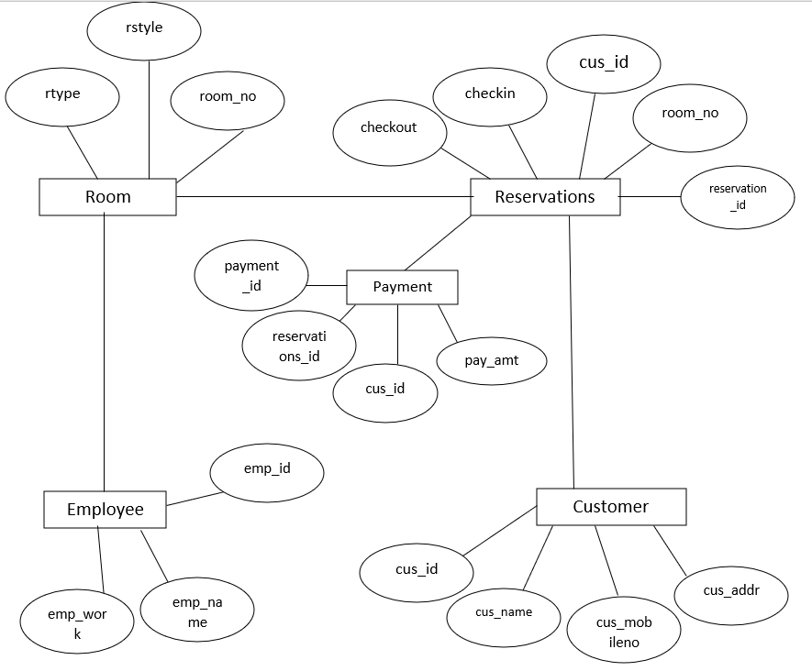

**TABLE CREATION:-**

**1] Customer**

create table customer

(cus_id varchar(4) constraint c_id Primary key constraint chc_id check (cus_id like 'C%'),

cus_name char(10) not null,

cus_mobile number(10) not null,

cus_addr char(10) not null);

insert into customer

values('C209','allen',9374648376,'panvel');

insert into customer

values('C210','ryan',9346474897,'Juinagar');

insert into customer

values('C211','sergio',9234764498,'thane');

insert into customer

values('C212','joshua',9385765732,'mulund');

insert into customer

values('C213','james',9354674822,'nahur');

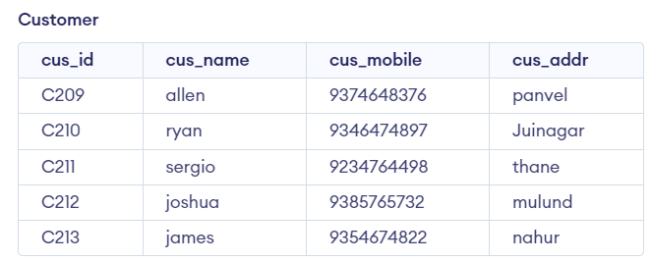

**2] Room**

create table room

(room_no varchar(4) constraint r_id Primary key constraint chc_rid check (room_no like 'R%'),

rstyle char(10) not null,

rtype char(10) not null);

insert into room

values('R102','suite','double');

insert into room

values('R104','deluxe','single');

insert into room

values('R204','deluxe','double');

insert into room

values('R205','suite','single');

insert into room

values('R301','standard','quad');

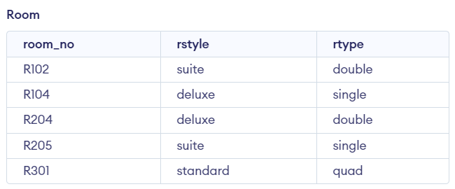

**3] Reservations**

create table reservations

(reservation_id varchar(4) constraint b_id Primary key constraint chb_id check (reservation_id like 'B%'),

room_no varchar(4) constraint chk_rid check (room_no like'R%'),

cus_id varchar(4) constraint chkc_id check (cus_id like 'C%'),

checkin date not null,

checkout date not null,

foreign key (cus_id) references customer(cus_id),

foreign key (room_no) references rooms(room_no));

insert into reservations

values('B001','R102','C209','14-july-2022','23-july-2022');

insert into reservations

values('B002','R104','C210','20-july-2022','29-july-2022');

insert into reservations

values('B003','R204','C211','17-aug-2022','30-aug-2022');

insert into reservations

values('B004','R205','C212','01-sep-2022','14-sep-2022');

insert into reservations

values('B005','R301','C213','10-sep-2022','15-sep-2022');

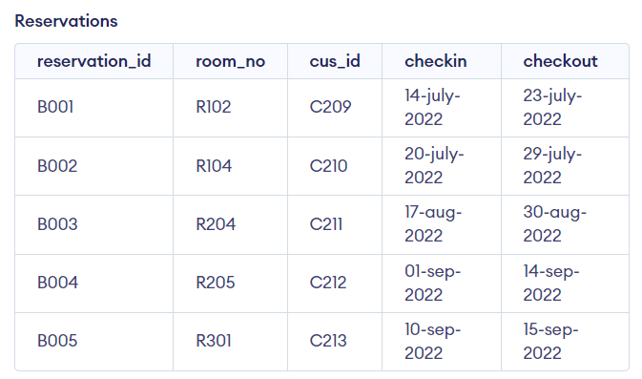

**4] Employee**

create table employee

(emp_id varchar(4) constraint e_id Primary key constraint chc_eid check (emp_id like 'E%'),

emp_name char(10) not null,

emp_work char(20) not null);

insert into employee

values('E001','jess','roomservice');

insert into employee

values('E002','alex','chef');

insert into employee

values('E003','sophia','receptionist');

insert into employee

values('E004','raj','guard');

insert into employee

values('E005','olivia','manager');

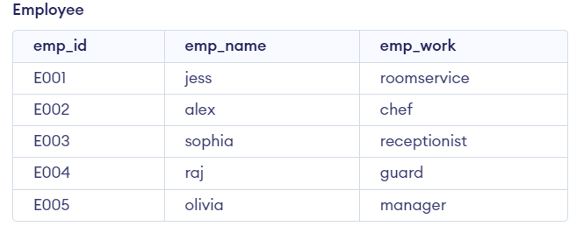

**5] Payment**

create table payment

(payment_id varchar(4) constraint p_id Primary key constraint chp_id check (payment_id like 'P%'),

reservation _id varchar(4) constraint chk_bid check (reservation _id like'B%'),

cus_id varchar(4) constraint chkc_id check (cus_id like 'C%'),

pay_amt number(8,2),

foreign key (reservation_id) references reservations(reservation_id)

foreign key (cus_id) references customer(cus_id));

insert into payment

values('P121','B001','C209',4000);

insert into payment

values('P122','B002','C210',6000);

insert into payment

values('P123','B003','C211',8000);

insert into payment

values('P124','B004','C212',9500);

insert into payment

values('P125','B005','C213',5500);

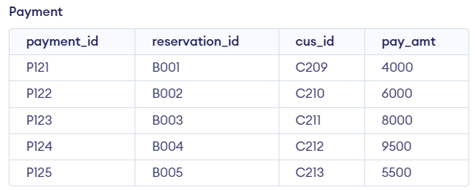

**QUERIES:-**

**1]** Display all the customer ID and Name, where all the names should be in descending order.

select cus_id, cus_name from customer

order by cus_name

DESC;

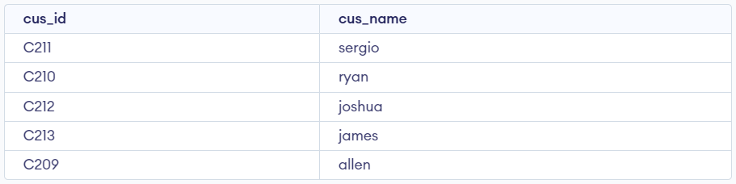

**2]** Create a view to display all the details of employees ‘sophia’ and ‘jess’.

create view sophia as

select * from employee

where emp_name='sophia'



create view jess as

select * from employee

where emp_name='jess'



**3]** Display all the customer Name, check in date, check out date.

select cus_name,checkin,checkout

from customer

left join reservations

on customer.cus_id=reservations.cus_id;

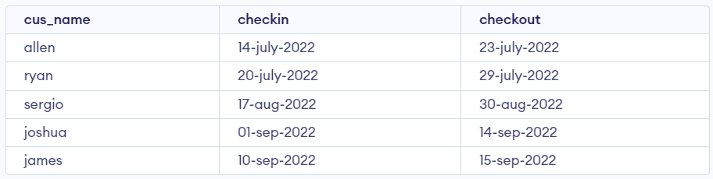

**4]** Display customer Name and payment amount who have paid more than 5000.

select cus_name,pay_amt

from customer,payment

where customer.cus_id=payment.cus_id

and pay_amt>5000;

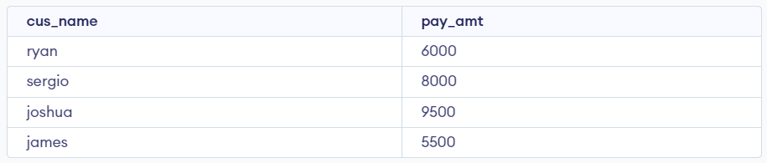

**5]** Display payment ID, customer ID, payment amount where payment amount should be less than average payment amount.

select payment_id,cus_id,pay_amt

from payment

where pay_amt<(select avg(pay_amt)from payment);

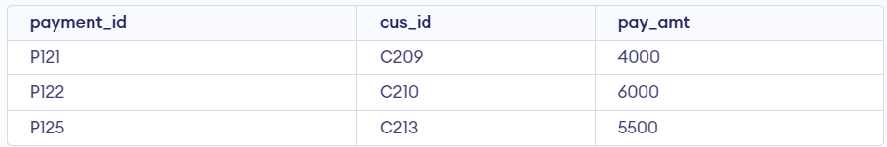

**6]** Display customer Name, room no, room style, room type.

select cus_name,reservations.room_no,rstyle,rtype

from customer,reservations,room

where customer.cus_id=reservations.cus_id

and reservations.room_no=room.room_no;

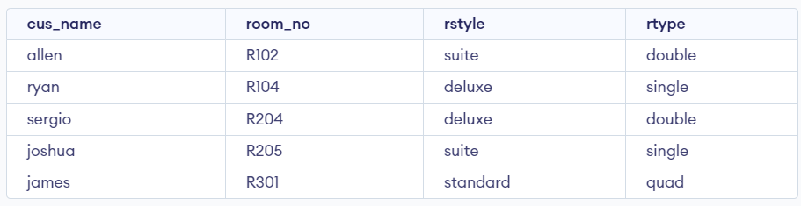

**7]** Update room style of room no ‘R102’.

update room

set rstyle='standard'

where room_no='R102';

select*from room

where room_no='R102'



**8]** Rename table employee to employees

rename employee to employees;

select*from employees;

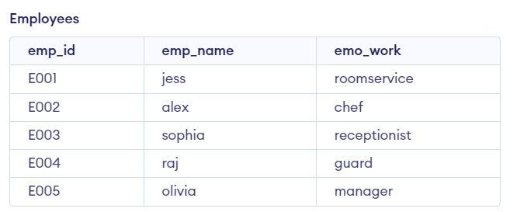

**9]** Truncate payment table.

truncate table payment;

select * from payment

SQL query successfully executed. However, the result set is empty.

**10]** Drop table room.

drop table room;